**Employee Management REST API Screenshots**

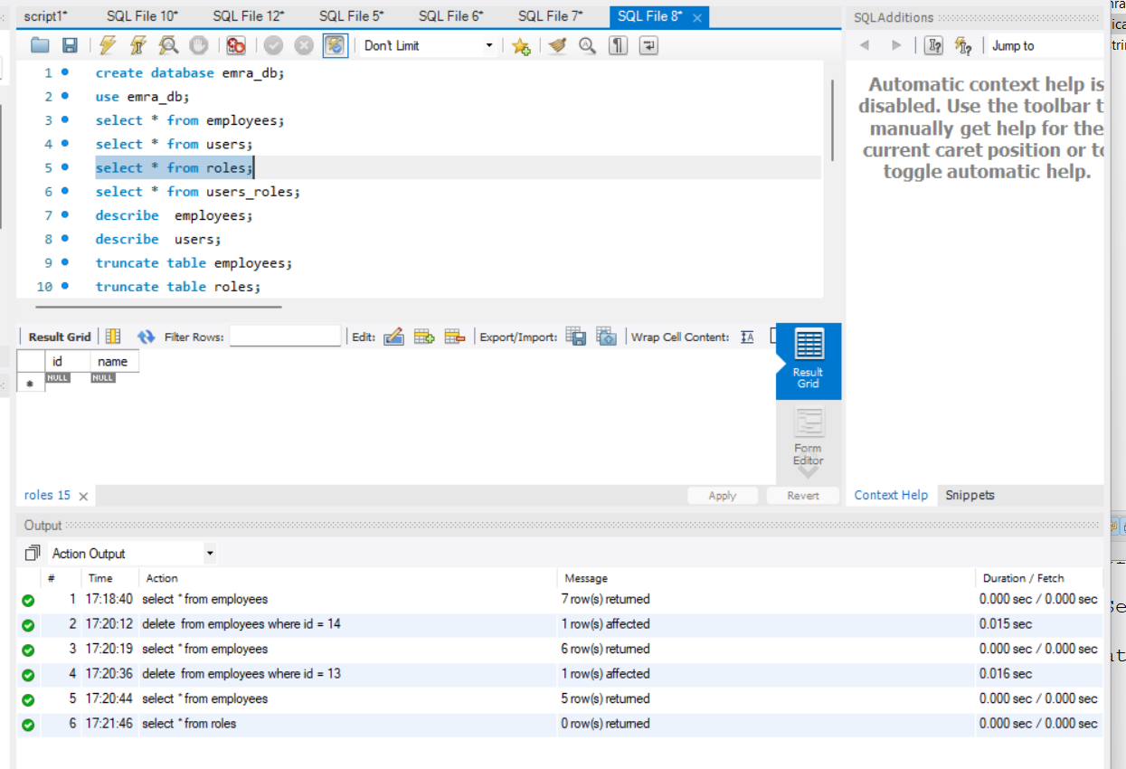

Pic: Blank Roles Table Before Role Insertion in DB.

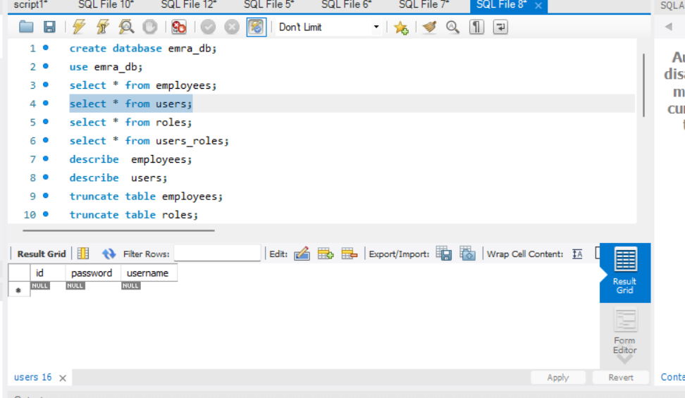

Pic: Blank Users Table Before User Insertion in DB.

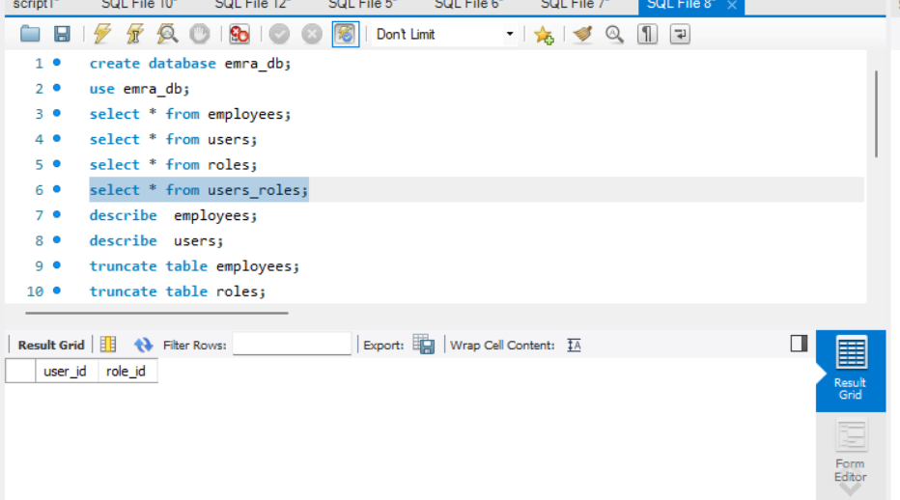

Pic: Blank Users_Roles Table Before Insertion in DB.

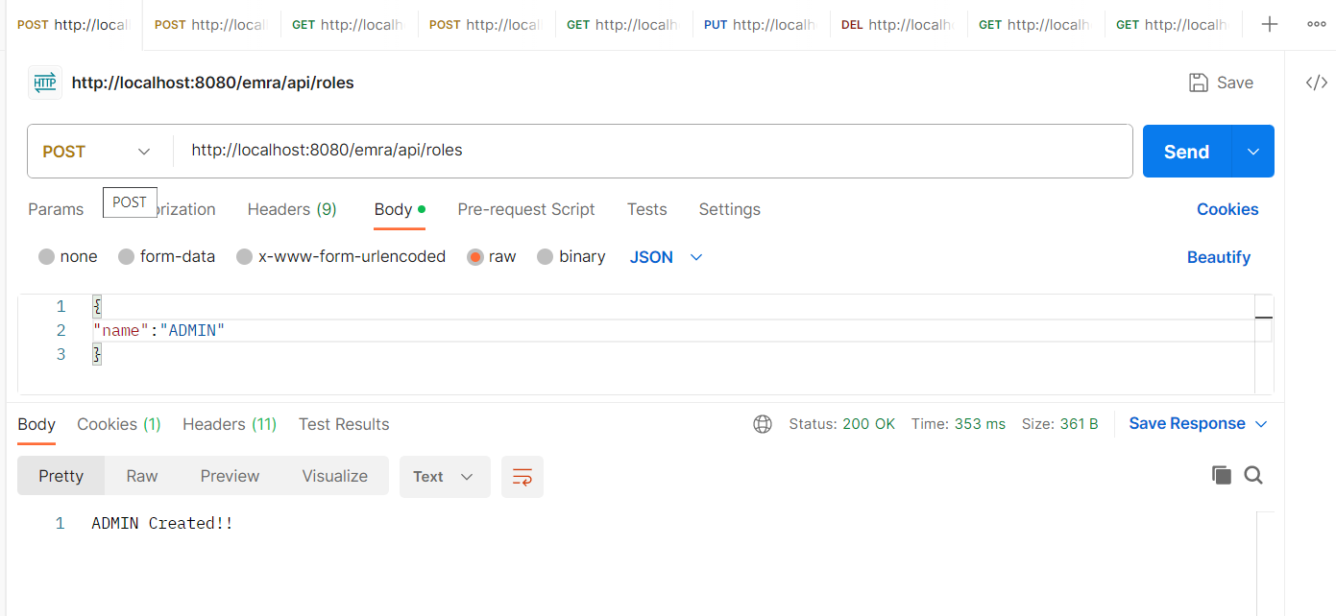

Pic: After the Role (ADMIN) Creation in POSTMAN.

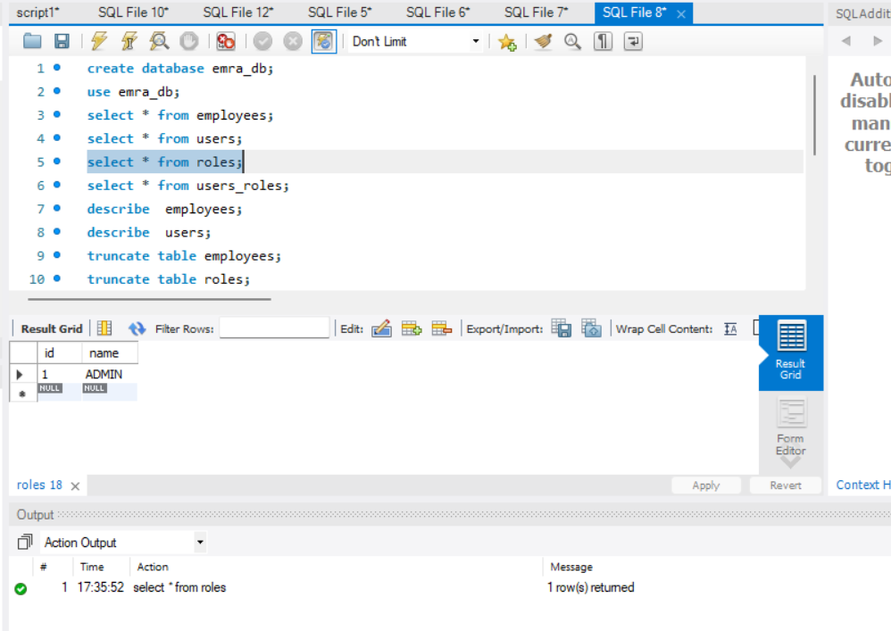

Pic: After the Role (ADMIN) Creation in the DB.

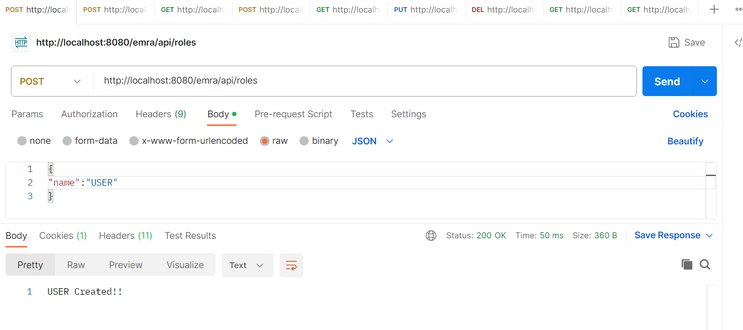

Pic: After the Role (USER) Creation in POSTMAN.

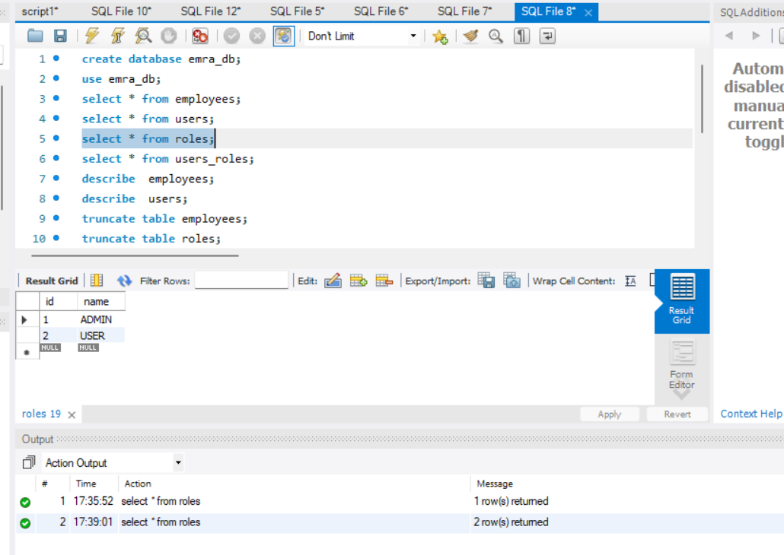

Pic: After the Role (USER) Creation in the DB.

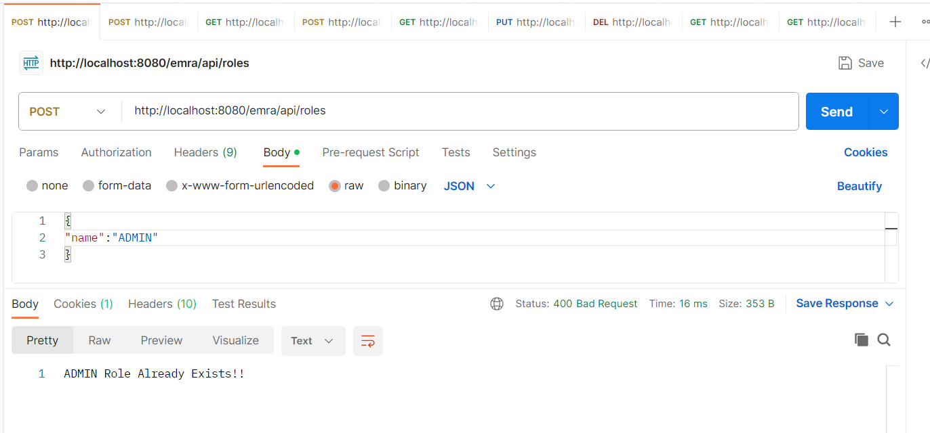

Pic: Restricting from Role Creation with the same role-name in POSTMAN.

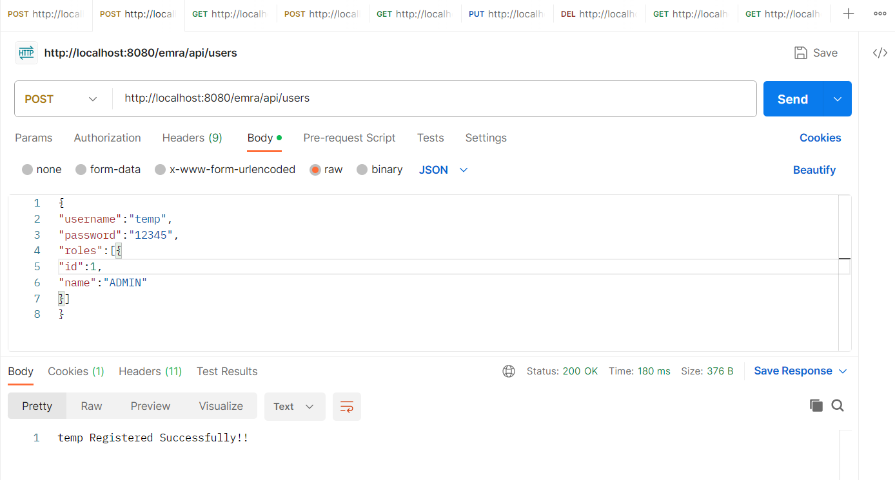

Pic: After the User (temp) Creation in POSTMAN.

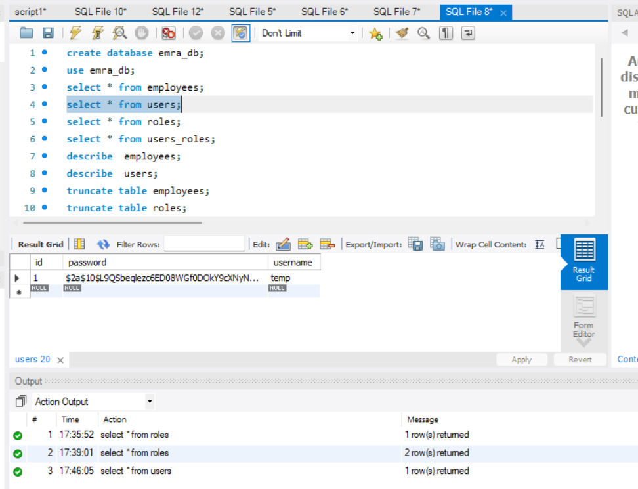

Pic: After the User (temp) Creation, the users table, in the DB.

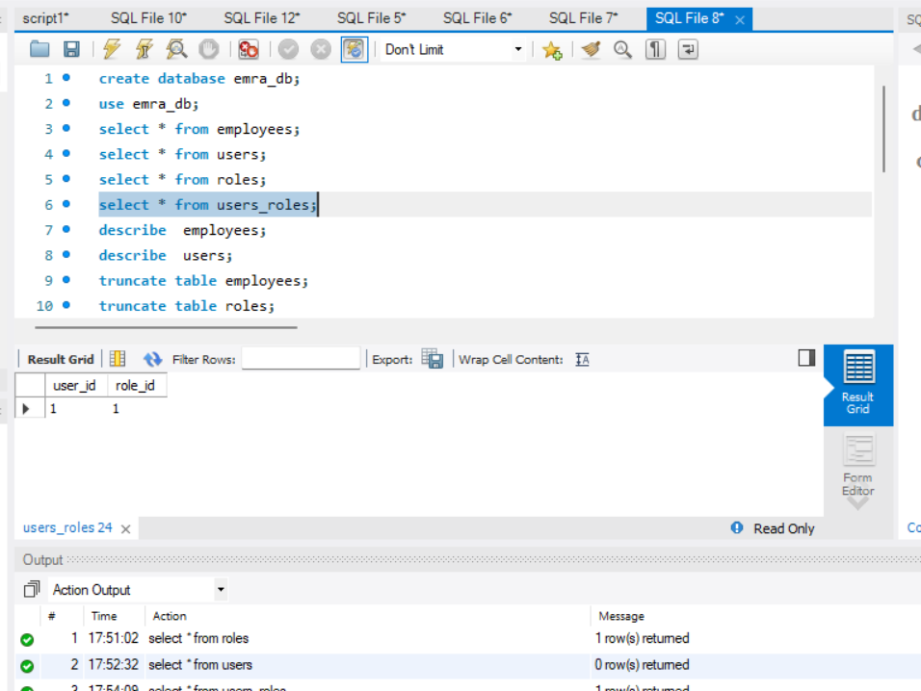

Pic: After the User (temp) Creation, the users_roles table, in the DB.

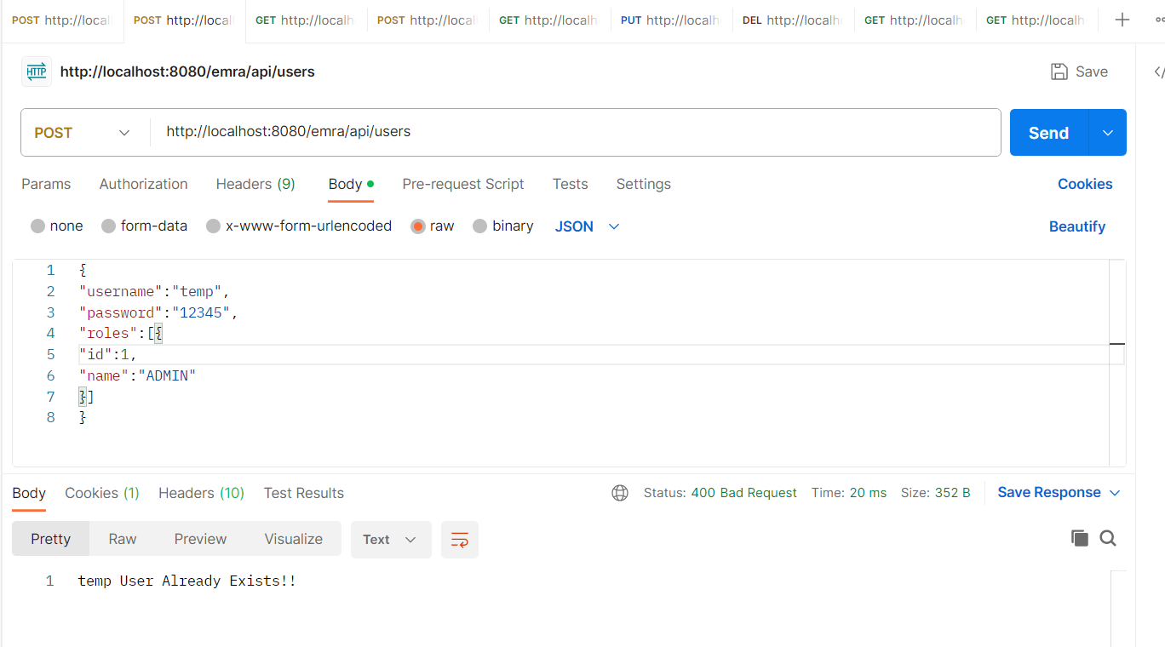

Pic: Restricting from User Creation with the same user-name in POSTMAN

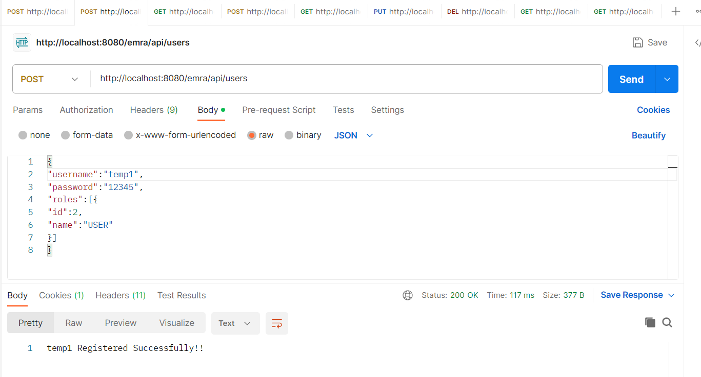

Pic: After the User (temp1) Creation in POSTMAN.

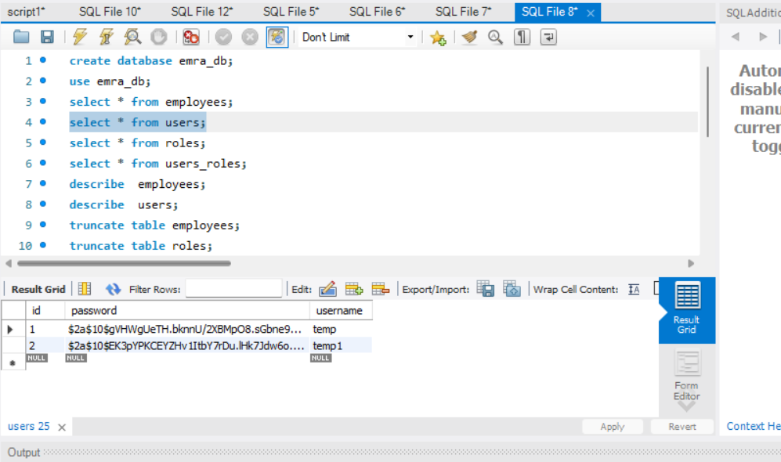

Pic: After the User (temp1) Creation, the users table, in the DB.

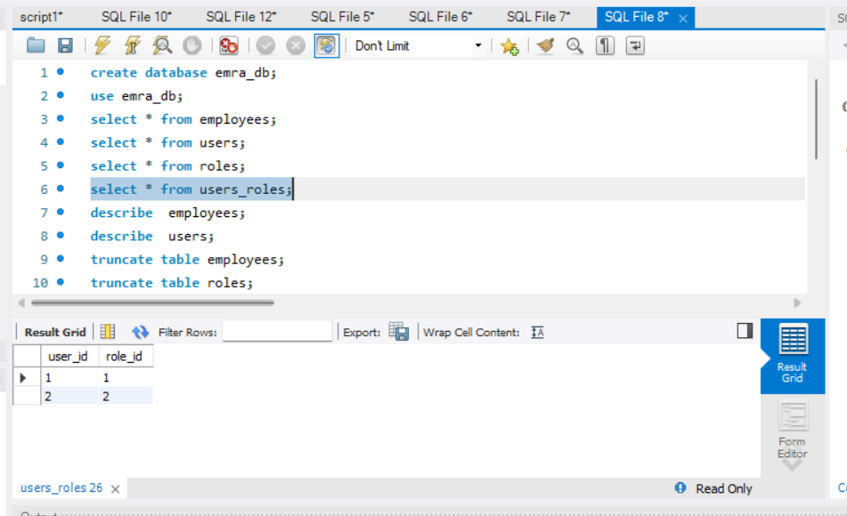

Pic: After the User (temp1) Creation, the users_roles table, in the DB.

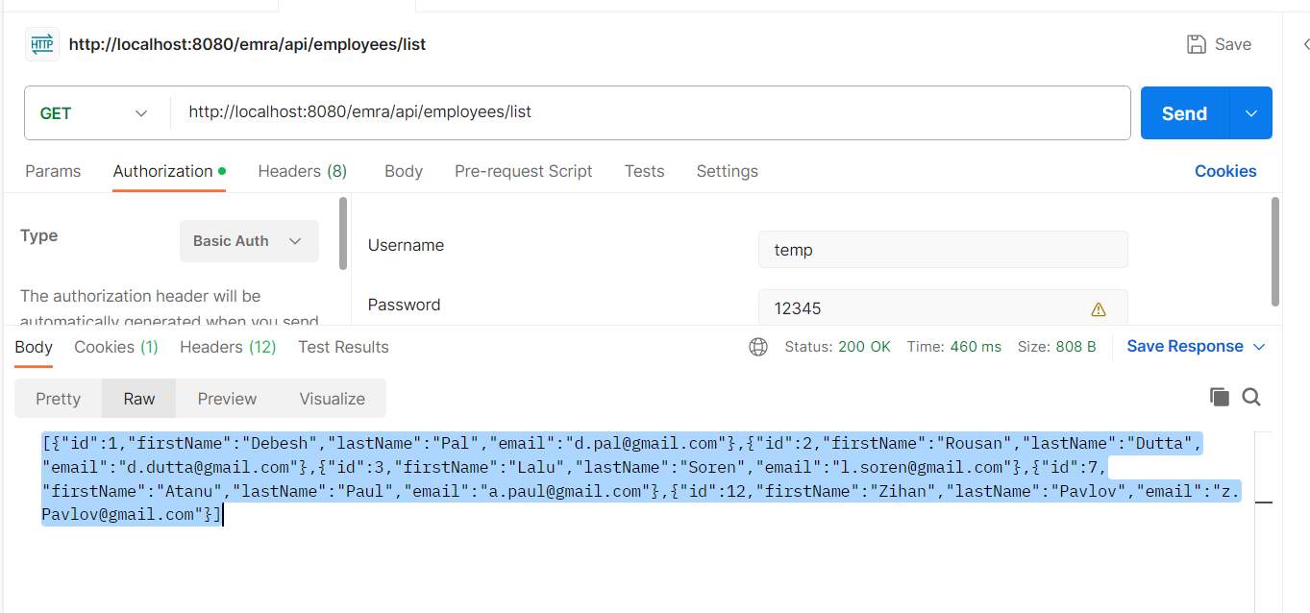

Pic: Listing all the records by the User (temp) Creation in POSTMAN.

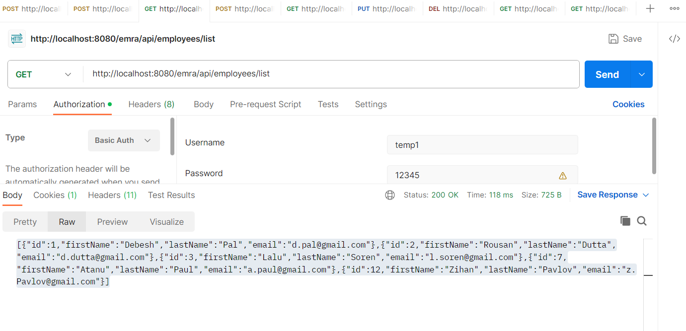

Pic: Listing all the records by the User (temp1) Creation in POSTMAN.

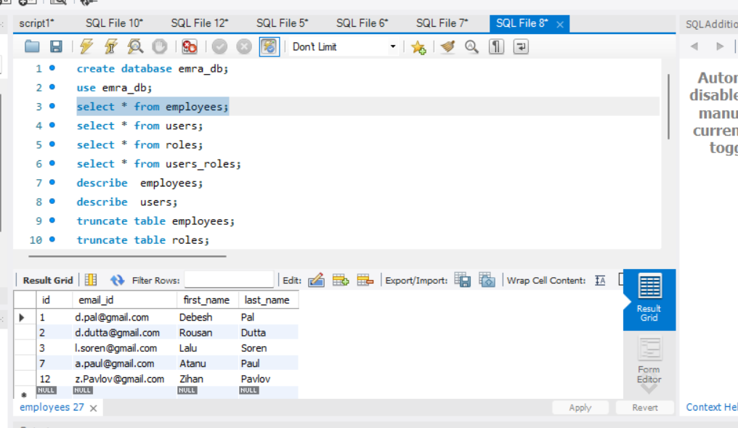

Pic: Before saving of the record of first_name = Prabhas, the DB picture.

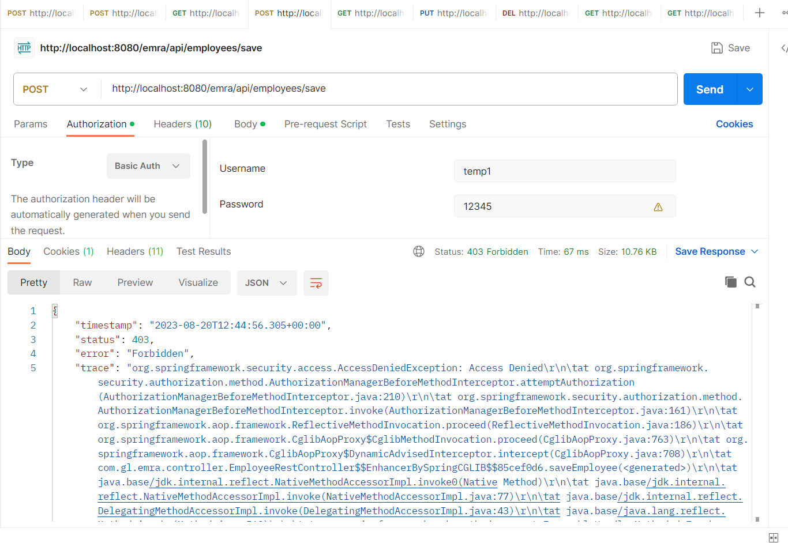

Pic: After the trying to save an employee by the User (temp1, that is normal user) POSTMAN.

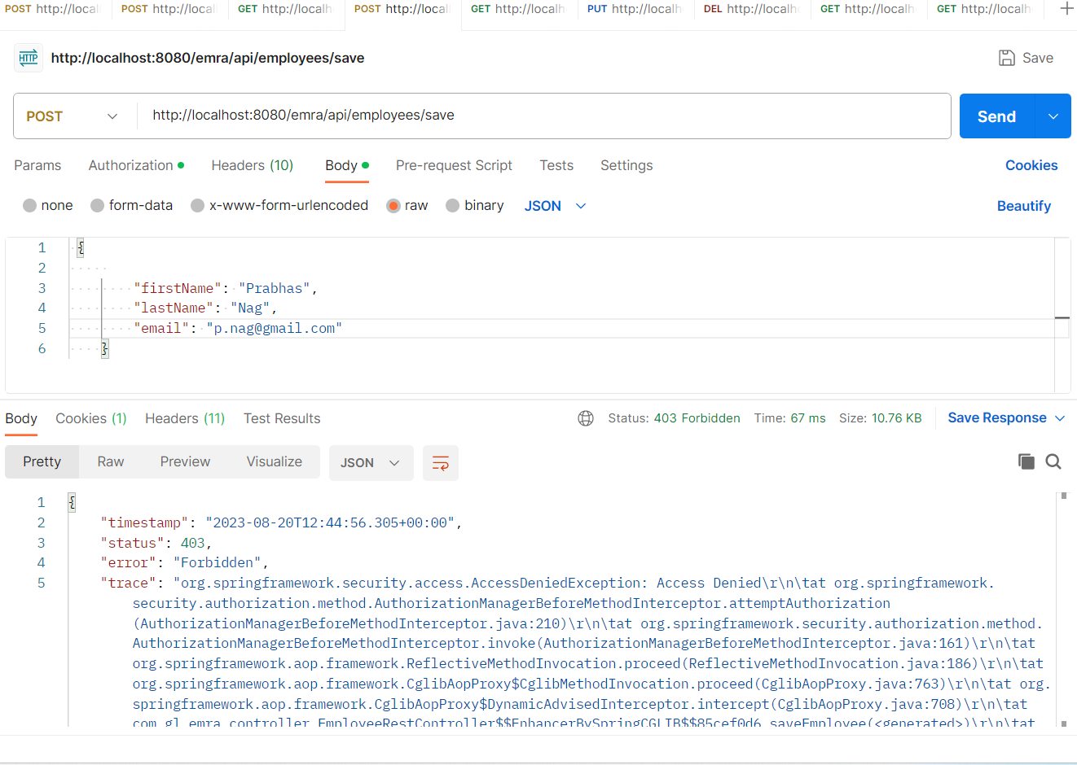

Pic: After the trying to save an employee by the User (temp1, that is normal user) POSTMAN.

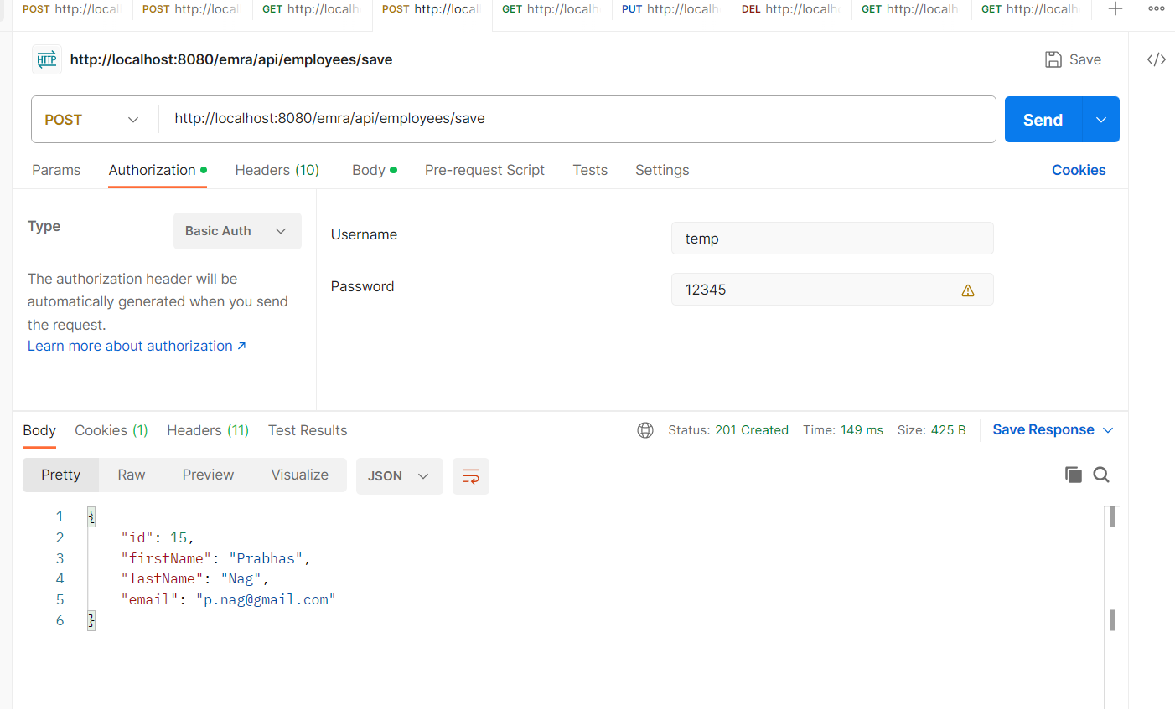

Pic: After the trying to save an employee by the User (temp, that is admin user), POSTMAN.

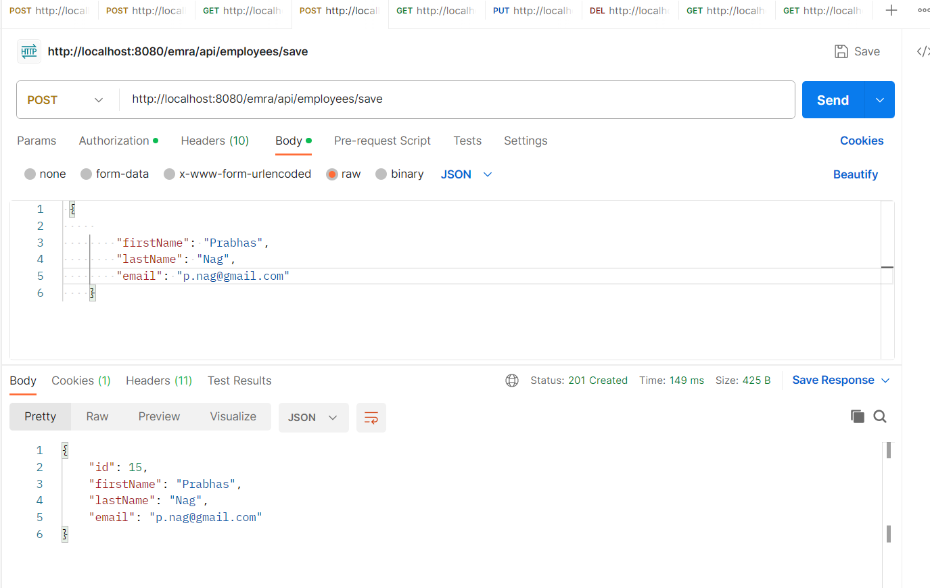

Pic: After the trying to save an employee by the User (temp, that is admin user), POSTMAN.

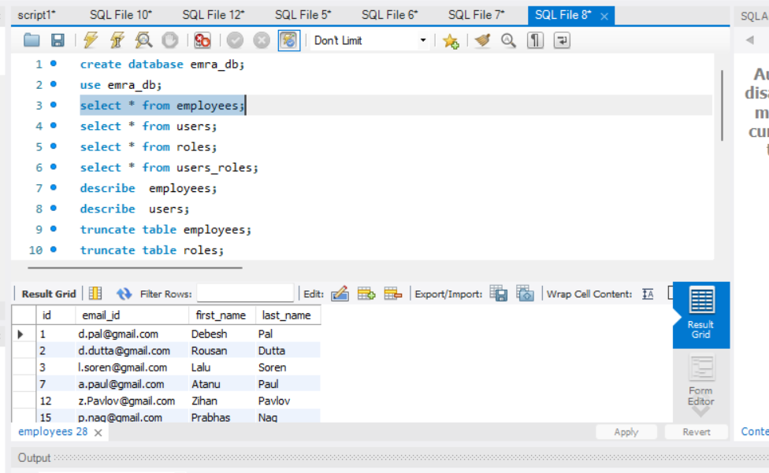

Pic: After the trying to save an employee by the User (temp, that is admin user), the DB.

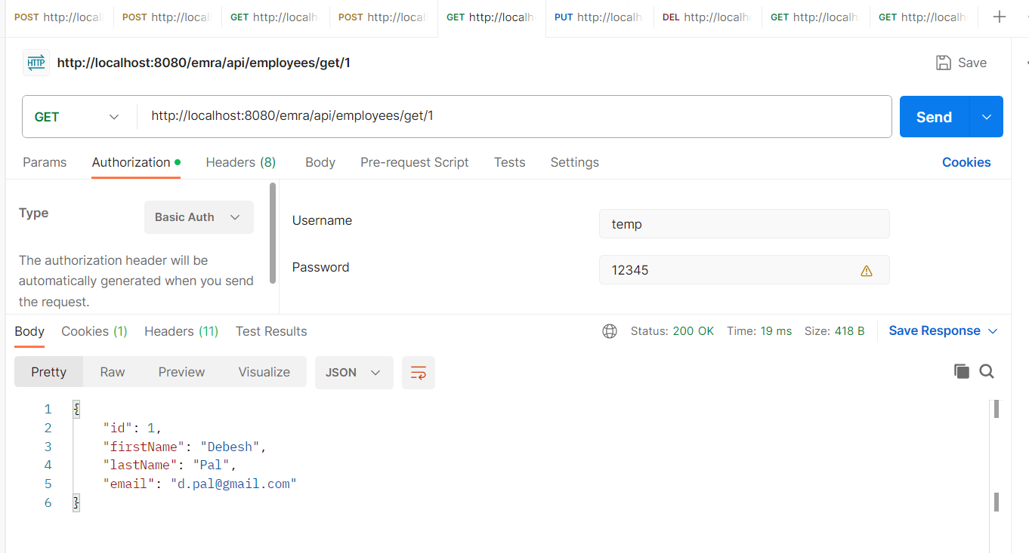

Pic: Get an employee by id the User (temp, that is admin user), the POSTMAN.

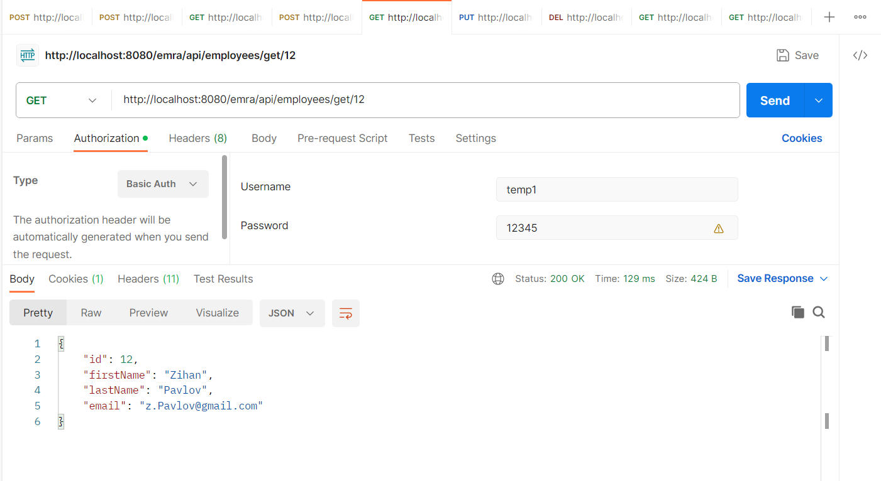

Pic: Get an employee by id the User (temp1, that is normal user), the POSTMAN.



Pic: Before Updation of an employee having id 2 by the User (temp, and temp1), the DB.

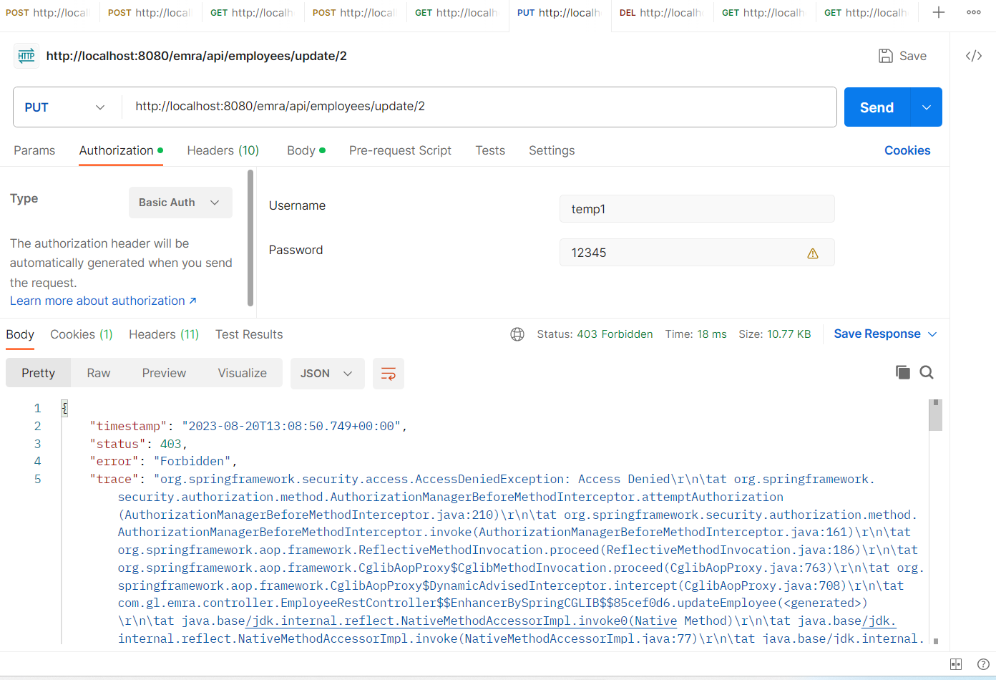

Pic: After the trying to update an employee having id=2, by the User (temp1, normal user) POSTMAN.

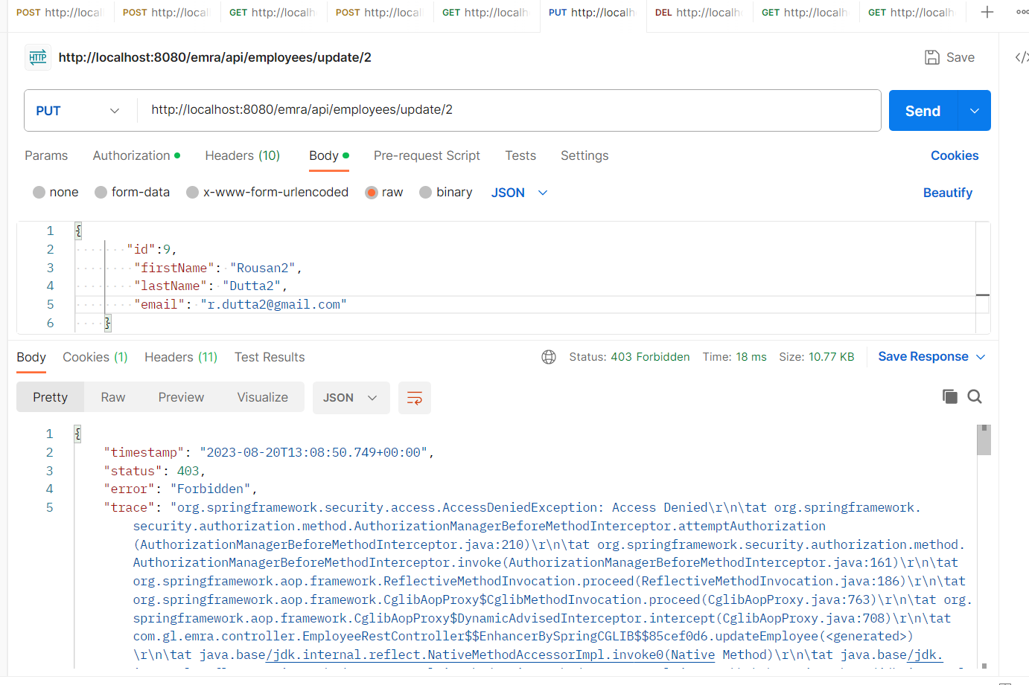

Pic: After the trying to update an employee having id=2, by the User (temp1, normal user) POSTMAN.

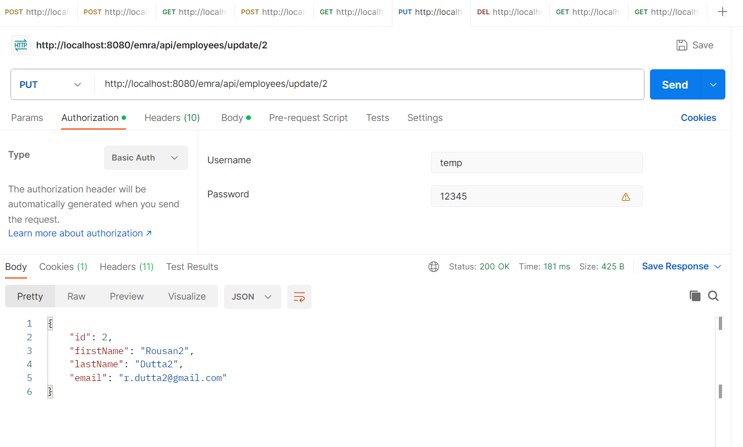

Pic: After the trying to update an employee having id=2, by the User (temp, admin user) POSTMAN.

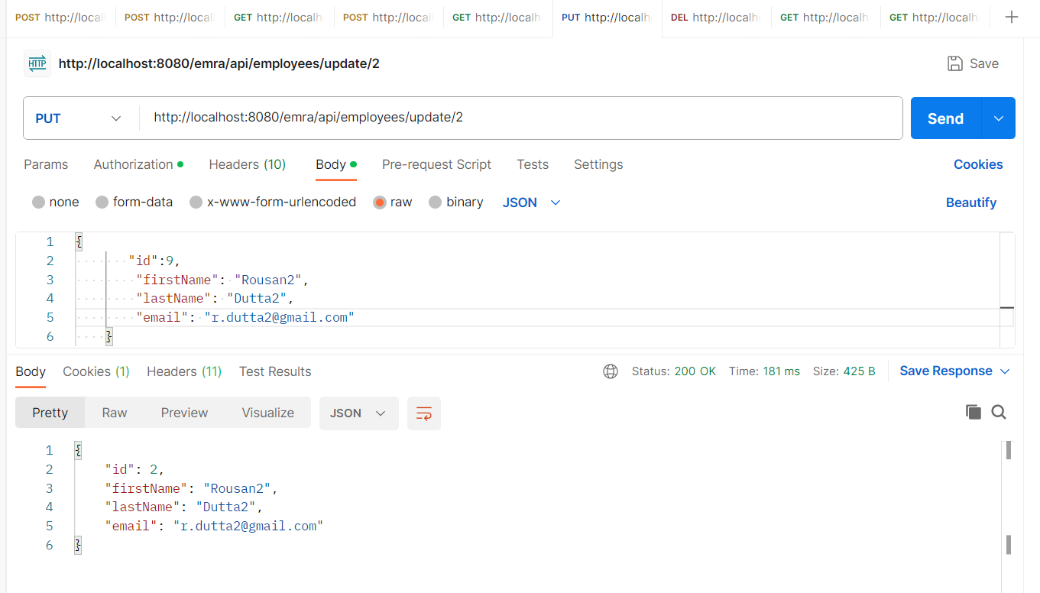

Pic: After the trying to update an employee having id=2, by the User (temp, admin user) POSTMAN.

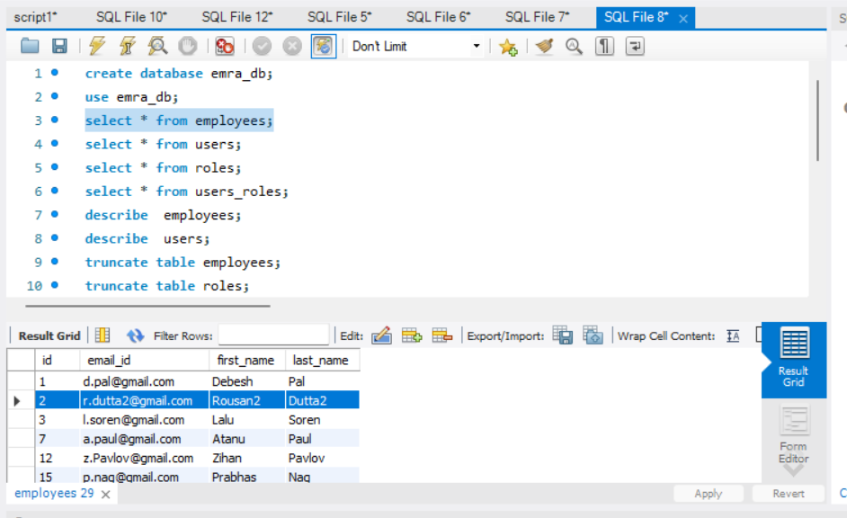

Pic: After the trying to update an employee having id=2, by the User (temp, admin user) the DB.

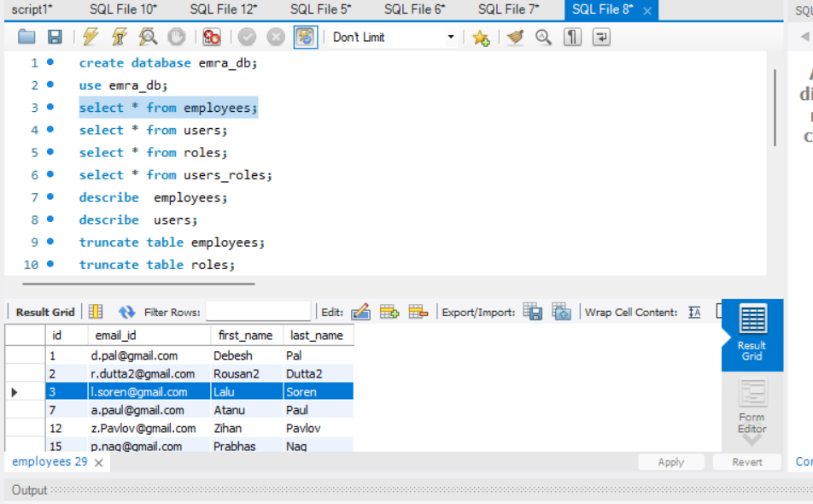

Pic: Before Deletion of an employee having id 3 by the User (temp, and temp1), the DB.

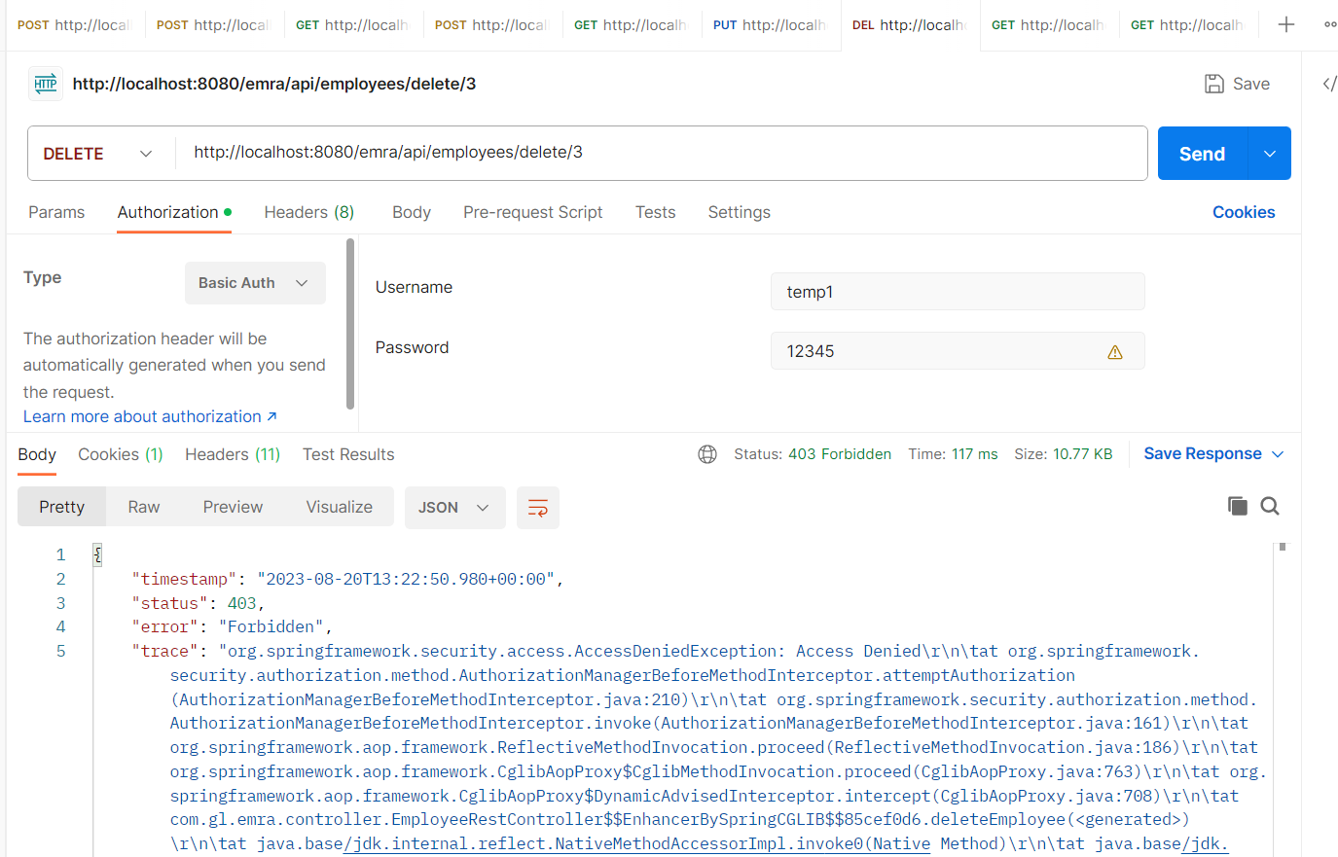

Pic: After the trying to delete an employee having id=3, by the User (temp1, normal user) POSTMAN.

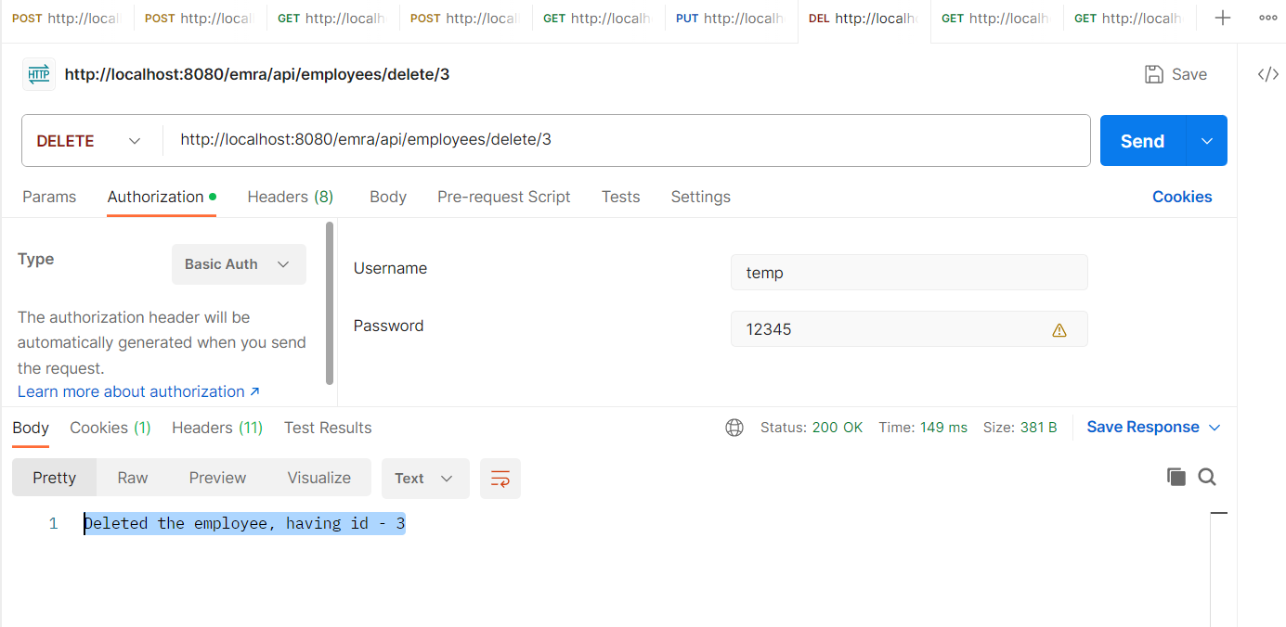

Pic: After the trying to delete an employee having id=3, by the User (temp, admin user) POSTMAN.

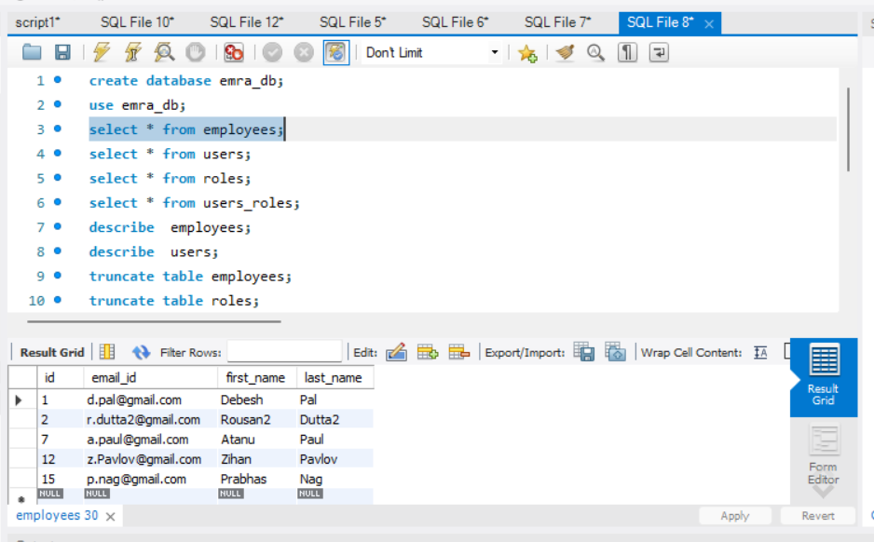

Pic: After the trying to delete an employee having id=3, by the User (temp, admin user) the DB.

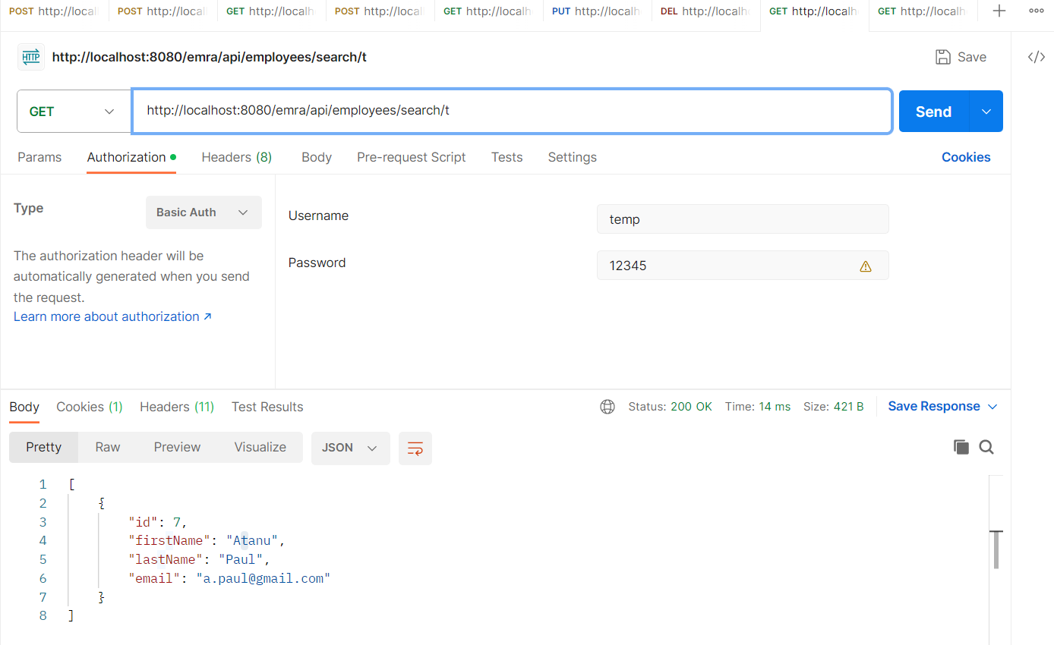

Pic: After the trying to search an employee having first_name with letter ‘t’, by the User (temp, admin user) POSTMAN.

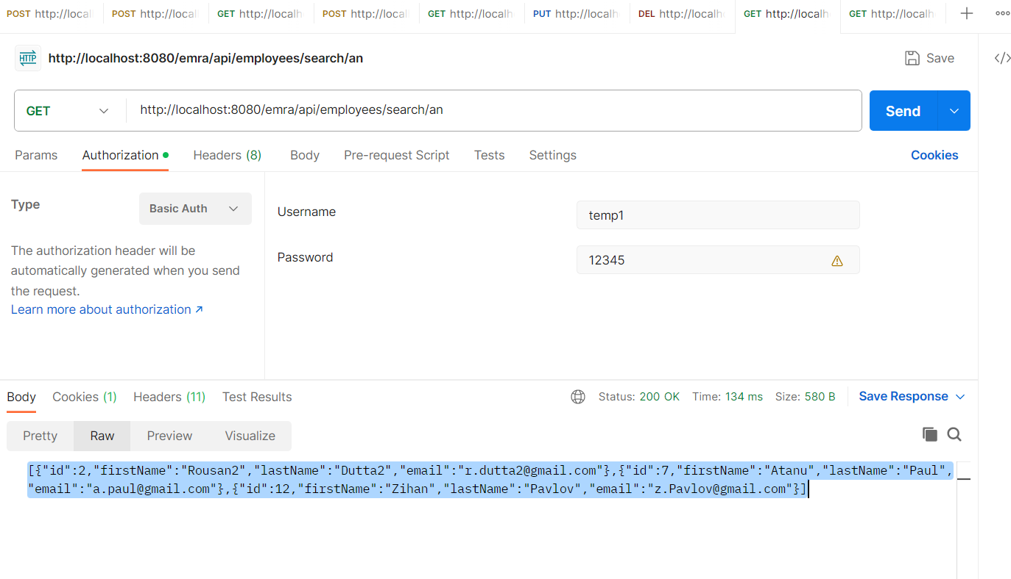

Pic: After the trying to search an employee having first_name with phrase ‘an’, by the User (temp1, normal user) POSTMAN.

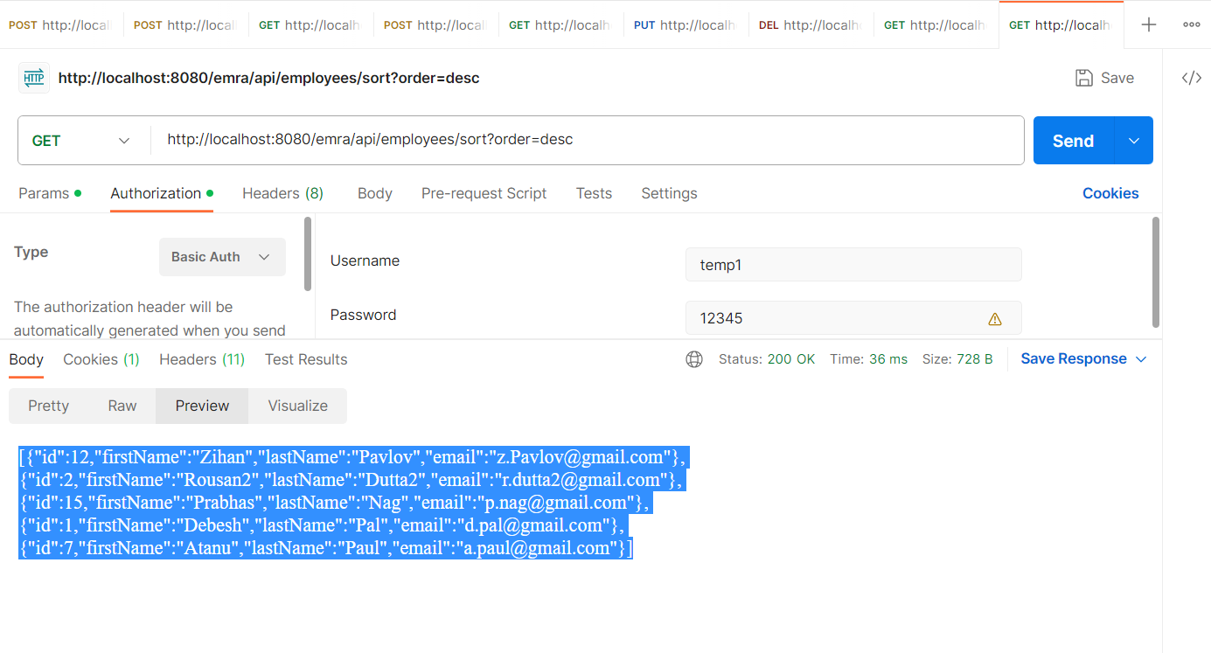

Pic: After the trying to sort in Descending Order on first_name by the User (temp1, normal user) POSTMAN.

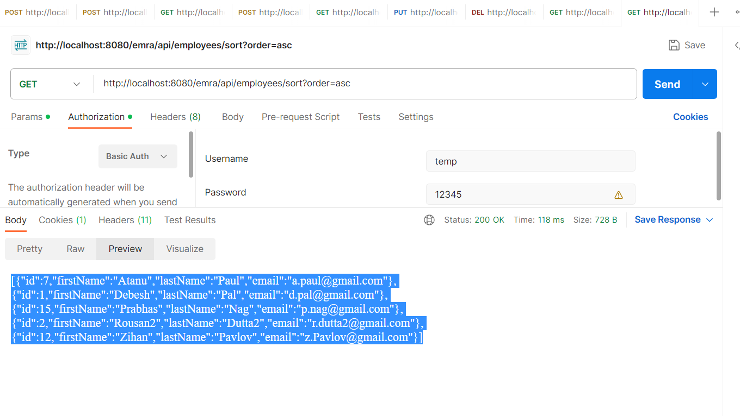

Pic: After the trying to sort in Ascending Order on first_name by the User (temp, admin user) POSTMAN.